Peanut Chicken with Soba Noodles

* [Nutrition](http://www.teambeachbody.com/teambeachbodyblog/category/nutrition)

* [Recipes](http://www.teambeachbody.com/teambeachbodyblog/category/nutrition/recipes)

March 25, 2015

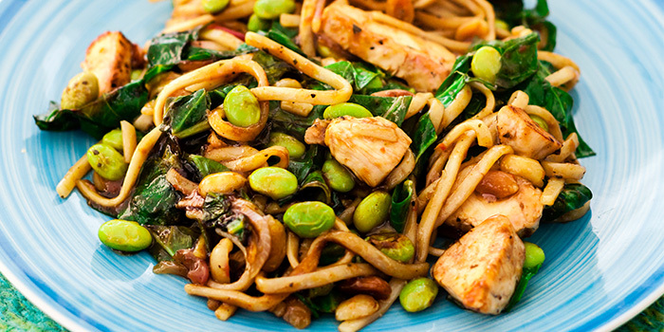

We used buckwheat soba noodles instead of pasta in this Asian-inspired chicken dish. It’s loaded with leafy greens, fresh edamame and crunchy peanuts. Enjoy hot or cold!

**Total Time:** 32 min.  
**Prep Time:** 20 min.  
**Cooking Time:** 12 min.  
**Yield:** 4 servings

**Ingredients:**  
½ cup low-sodium organic chicken broth  
1 Tbsp. all-natural peanut butter  
1 Tbsp. reduced-sodium soy sauce  
1 Tbsp. raw honey  
2 cloves garlic, finely chopped  
1 thin slice fresh ginger, peeled, finely chopped  
1 tsp. coconut oil  
12 oz. raw chicken breast, boneless, skinless, cut into 2-inch pieces  
½ medium onion, thinly sliced  
2 cups fresh spinach (or chopped baby bok choy)  
1 cup fresh shelled edamame  
2 cups cooked soba noodles (about 4 oz. dry noodles)  
1 tsp. crushed red pepper (optional)  
2 Tbsp. raw peanuts

**Preparation:**  
1. Combine broth, peanut butter, soy sauce, honey, garlic, and ginger in a medium bowl; whisk to blend. Set aside.  
2. Heat oil in large skillet (or wok) over medium-high heat.  
3. Add chicken and onion; cook, stirring frequently, for 4 to 6 minutes, or until onion is translucent.  
4. Add spinach; cook, stirring frequently, for 2 to 3 minutes, or until spinach is wilted.  
5. Add edamame, noodles, broth mixture, red pepper (if desired), and peanuts; cook, stirring frequently, for 2 to 3 minutes, or until heated through.

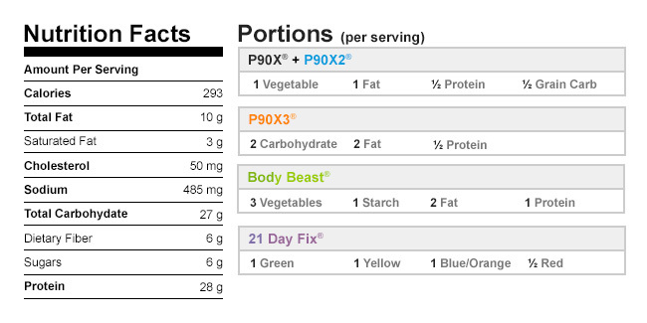

Authors

[Beachbody](http://www.teambeachbody.com/teambeachbodyblog/author/beachbody)

Tags[chicken](http://www.teambeachbody.com/teambeachbodyblog/tag/chicken), [dinners](http://www.teambeachbody.com/teambeachbodyblog/tag/dinners),[lunches](http://www.teambeachbody.com/teambeachbodyblog/tag/lunches), [pastas](http://www.teambeachbody.com/teambeachbodyblog/tag/pastas), [recipes](http://www.teambeachbody.com/teambeachbodyblog/tag/recipe)